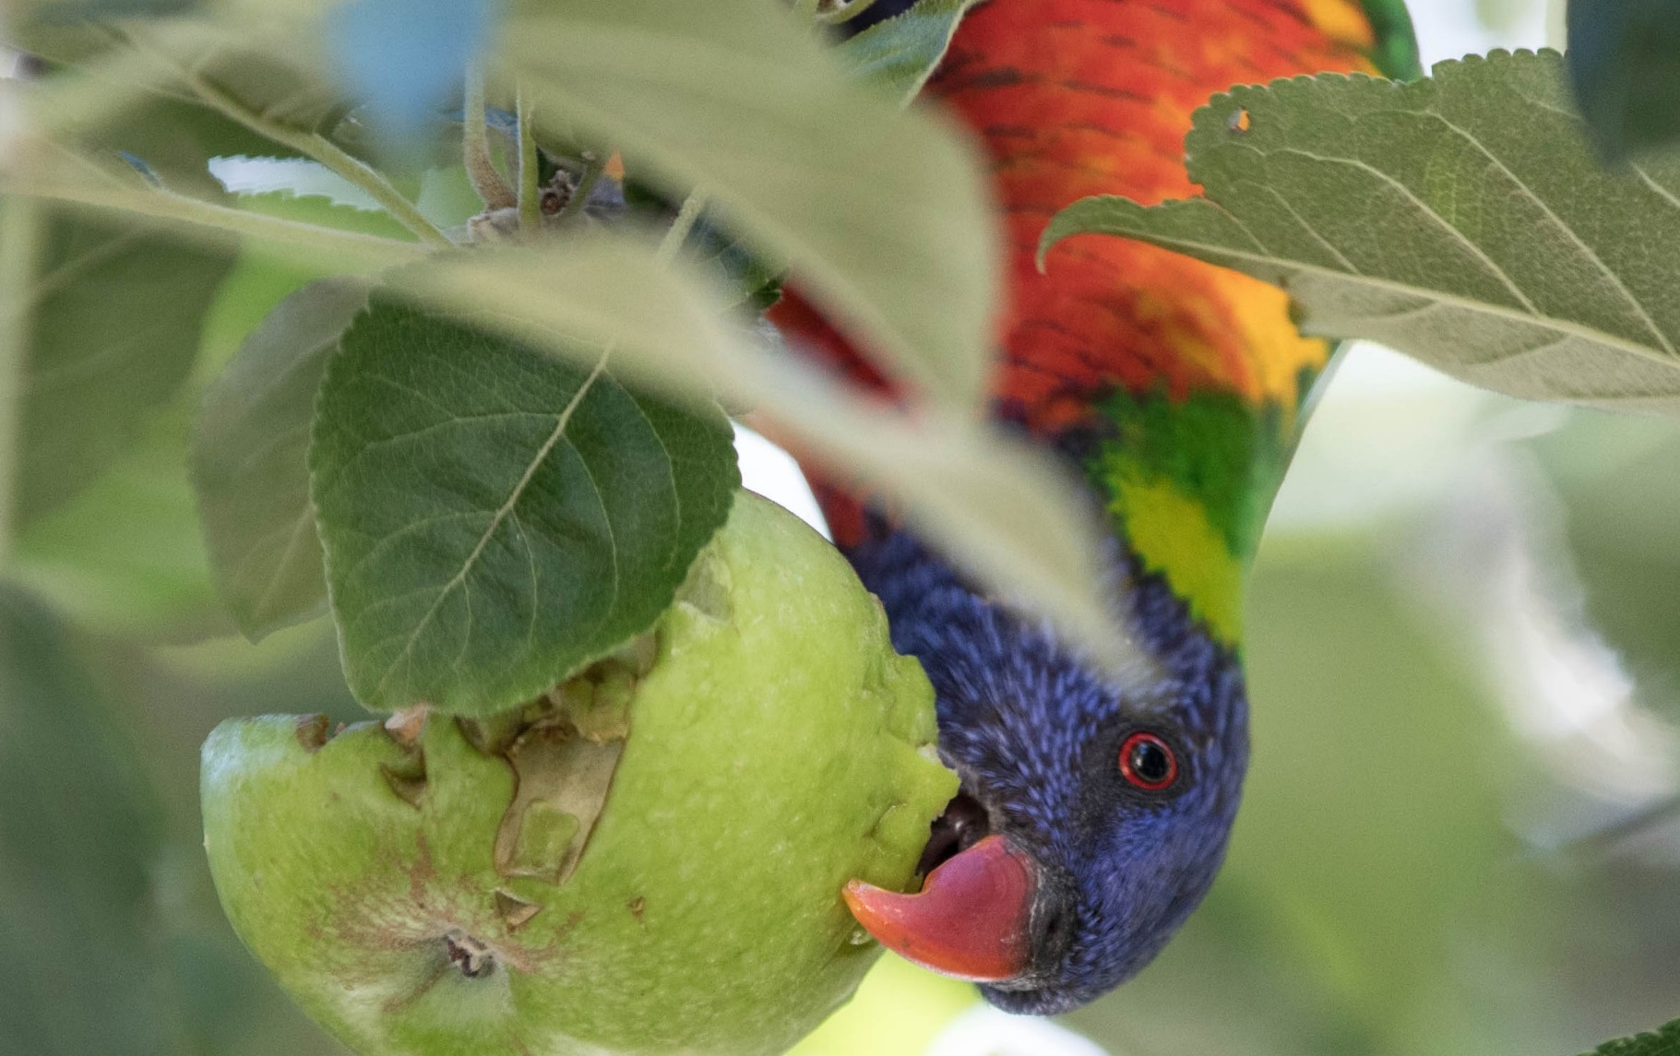
The Authority to Control Wildlife
(ATCW) system review

Discussion Paper




Photo credit
All photographs have been supplied by Marcia Riederer unless otherwise credited.

© The State of Victoria Department of Environment, Land, Water and Planning 2018.

ISBN 978-1-76077-033-4 (pdf/online/MS word)

Disclaimer

This publication may be of assistance to you but the State of Victoria and its employees do not guarantee that the publication is without flaw of any kind or is wholly appropriate for your particular purposes and therefore disclaims all liability for any error, loss or other consequence which may arise from you relying on any information in this publication.

Contents
Introduction 3
Theme 1: The Application Process 6
What we have heard so far 8
Ideas for improvement 10
Questions 10
Theme 2: Decision making 11
What we have heard so far 16
Questions 17
Theme 3: Compliance Monitoring and Enforcement 18
What we’ve heard so far 22
Ideas for improvements 23
Questions 23
Theme 4: Traditional Owner involvement in the ATCW system 24
Questions 24
Theme 5: Information provision 25
What we’ve heard so far 26
Questions 28
Ideas for improvements 28
Broader issues 29
How to participate in the review 32

Introduction

Wildlife in Victoria are protected under the Wildlife Act 1975 (Wildlife Act). The Wildlife Act is administered by the Victorian Department of Environment, Land, Water and Planning (DELWP) and provides the framework to:
- protect and conserve wildlife
- prevent wildlife species from becoming extinct
- enable the sustainable use of, and access to, wildlife
- regulate or prohibit people’s actions in relation to wildlife.

It is crucial to appreciate that the intention of the Wildlife Act is not to protect all specimens of wildlife at all times and in any circumstances from activities that may impact them. Rather, the Wildlife Act enables activities relating to wildlife to be regulated, thereby allowing oversight of the activities to ensure they are necessary, do not impact on the sustainability of species or result in poor animal welfare outcomes. The Wildlife Act also enables compliance and enforcement activities to be undertaken against persons who commit breaches against the Wildlife Act.
The Wildlife Act is very prescriptive as to what activities relating to wildlife may or may not be undertaken, for what reason, by whom, where and for how long.

Did you know?
The Wildlife Act and Wildlife Regulations are available for download from: www.legislation.vic.gov.au

The Authority to Control Wildlife system
Section 28A of the Wildlife Act allows the Secretary (or a delegate) to issue an authorisation to allow a person to undertake a number of different activities relating to wildlife. Under this section of the Act, authorisations can be issued for any of the following activities:
- hunt, take or destroy wildlife
- buy, sell, acquire, receive, dispose of, keep, possess, control, breed, process, display, take samples from or experiment on wildlife
- mark wildlife, handle wildlife for the purpose of marking it and interfere with the markings on wildlife.

The Authority to Control Wildlife (ATCW) system has been set up specifically to administer and regulate the following activities:
- take wildlife (e.g. trap)
- destroy wildlife
- disturb wildlife or cause wildlife to be disturbed (e.g. scaring).

All other activities that can be authorised under Section 28A are managed through separate systems and are therefore not part of this review.
To issue an ATCW, the Secretary or delegate must be satisfied the authorisation is necessary for one of the following reasons:
- because wildlife is damaging a building, vineyard, orchard, crop, tree, pasture, habitat or other property
- for the management, conservation, protection or control of wildlife (e.g. where wildlife are impacting on biodiversity values)
- to ensure the health or safety of people
- to support a recognised wildlife management plan.

The need for control of wildlife can occur in both urban and rural environments. Problems and damage caused by wildlife can range from small scale suburban issues, such as possums causing damage by nesting in residential roofs, to those that result in financial losses to businesses, such as flying foxes or lorikeets damaging fruit orchards.
Did you know?
If the Minister is satisfied that a species of protected wildlife is causing injury or damage in an area of Victoria, then, under Section 7A of the Wildlife Act, the Minister can recommend to the Governor in Council to declare a species of wildlife unprotected in that area.
Whilst this means that the unprotected species of wildlife may be controlled without an ATCW, it does not mean that control is not regulated. Rather, the unprotection order will specify the period and area to which the Order applies, in what circumstances the species is unprotected, and the conditions that must be met, such as who may control the species and the methods they may use.
There are currently unprotection orders in place for the Common Wombat in certain parishes of Victoria, Brush-tail Possums living in buildings and municipal parks, Dingos on or within a certain distance from private land and Long-billed Corellas, Sulphur-crested Cockatoos and Galahs causing damage to property.
Active management of wildlife may also be needed where native animals are suffering from starvation or disease. It may also be needed where overabundant wildlife are having an impact on biodiversity values by over-grazing native vegetation and promoting the dominance of other plant species, which then impact the local ecosystem.
Active management can also be required to avoid risks to human safety, such as aggressive kangaroos in residential areas.
DELWP advocates non-lethal management of wildlife, for example using fencing to exclude wildlife from an area, installing netting around fruit trees to protect crops, using gas guns to scare birds away or using decoy feeding to reduce the impact of wildlife on crops. However, in some situations, non-lethal methods are ineffective, impractical, costly or inhumane and it can be necessary to supplement these with lethal control.
ATCW Data
4,049 ATCWs were issued in 2017. The most common species that ATCWs were issued for in 2017 were the Eastern Grey Kangaroo (2732 authorisations), Common Wombat (252 authorisations) and Maned Duck
(109 authorisations issued). However, the Eastern Grey Kangaroo, Western Grey Kangaroo and Red Kangaroo were the species with the highest number of individual animals authorised for control in 2017 (161,331, 12,568 and 15,187 authorised for control respectively).
These figures include ATCWs for both lethal and non-lethal control, and are the maximum number which may be controlled (i.e. the actual number of animals controlled may be lower). As a transparent regulator, DELWP publishes ATCW data on the website at: www.wildlife.vic.gov.au/ managing-wildlife/wildlife-management- and-control-authorisations

Context for the review
The ATCW system seeks to balance the objectives of the Wildlife Act; the conservation and protection of wildlife in Victoria, while allowing for it to be controlled when necessary. Over the last few years there has been increasing community interest in the way the ATCW system is managed. Community members have raised specific concerns with DELWP about the system and have provided suggestions for how they feel it could be improved.
DELWP understands that there are very polarised views about the ATCW system in the community, which is understandable given the diverse make-up of the Victorian community and that the system allows the lethal control of animals in certain circumstances.
It is important to note that DELWP is not considering removing the ability for people to undertake lethal control of wildlife when it is necessary. Removing this option would deprive affected parties of the ability to legally control wildlife when non-lethal options are not available, impractical or pose significant risks to animal welfare. It would also likely result in perverse outcomes where previously legal control activities would be undertaken illegally without regulatory oversight, potentially leading to inhumane treatment or suffering of wildlife.
The aim of the review is to develop stakeholder informed recommendations on how to improve the ATCW system so that it sensibly balances the needs of Victoria’s human and wildlife populations.
The first formal step of the review is to engage with the public via this discussion paper. The purpose of the paper is to provide readers with:
- an overview of the ATCW system as it currently operates
- information on changes and improvements to the ATCW system that are planned or already underway
- a description of issues and solutions previously raised by stakeholders
- an opportunity to identify issues not already included in this paper; and
- an opportunity to propose ideas, solutions or provide commentary on individual issues for consideration by DELWP.

How to get involved
This discussion paper has been developed to assist you (the Victorian community) to provide us
with feedback on ways that the ATCW system could be improved.
It includes the following sections:
Theme 1 — Application Process
Theme 2 — Decision Making
Theme 3 — Compliance Monitoring and Enforcement
Theme 4 — Traditional Owner Involvement in the ATCW System
Theme 5 — Information Provision Broader Issues

Each theme includes an explanation of how the ATCW system currently operates, outlines issues and solutions that we have heard from stakeholders so far and provides some additional suggestions for ways that the system could be improved.
We also want to know whether there are other issues with the ATCW system that are important to you that we have not captured, or any other suggestions you might have for how the system could be improved.
To assist you to respond to this discussion paper we have included questions at the end of each theme to prompt your thinking.
The Broader Issues section outlines concerns that stakeholders have raised during early consultation that relate to wildlife control, but are outside the scope of this review. While these issues will not be addressed through the review process, we thought that it was important to acknowledge these issues and provide further information about them in this discussion paper.
DELWP has set up a consultation webpage where you can provide your responses to this discussion paper: engage.vic.gov.au/atcwreview
Your feedback will help shape the recommendations for improvements to the ATCW system.

Theme 1: The Application Process

This theme explains the current ATCW application process and discusses concerns that stakeholders have raised with us about the application process so far. It also presents some ideas for ways these concerns can be addressed.

Managing wildlife impacts: when is an ATCW needed
Some indirect wildlife management methods, such as exclusion of kangaroos or birds through fencing or netting, or deterring kangaroos from the property by altering watering regimes (e.g. watering stock using stock activated troughs rather than dams), do not require an ATCW.
Likewise, some forms of disturbing wildlife, such as putting up a scarecrow, do not require an ATCW. However, all lethal control and most forms of direct non-lethal control, such as actively scaring or dispersing wildlife (e.g. by using a gas gun to frighten birds from an orchard), require that an ATCW is obtained prior to undertaking any control activity. It is DELWP policy that all practical non-lethal control options must be exhausted before an ATCW for lethal control can be applied for.

Pre-application checks
Before taking any wildlife management action or lodging an ATCW application, DELWP encourages land owners or managers impacted by wildlife to contact their regional DELWP Forest and Wildlife Officer who can assist in identifying:
- the species responsible for the damage
- (e.g. rather than wildlife it may be that a pest species is causing the damage)
- the cause of the problem (e. g. the species doing the damage might be attracted to a property because food or water is available)
- potential solutions that may not require an ATCW (e.g. installing rolling perches to prevent cockatoos landing on light fixtures, netting fruit to exclude birds).
DELWP also provides information about wildlife management and the ATCW system on the DELWP website: www.wildlife.vic.gov.au/managing-wildlife/ wildlife-management-and-control-authorisations

Submitting an ATCW application
If it is considered necessary to control wildlife to resolve the problem, then land owners or land managers will need to fill in, sign and submit an ATCW application form.
The form can be downloaded from the DELWP website at: wildlife.vic.gov.au/managing-wildlife/ wildlife-management-and-control-authorisations or a hard copy can be obtained from a regional DELWP office, or through the DELWP Customer Contact Centre on 136 186.
Applicants are required to fill in all applicable fields and submit completed application forms by fax, post, email or in person to the DELWP office nearest to the property location.
Did you know?
DELWP is in the process of developing a new online wildlife licensing and authorisation system (OWLS), which will allow customers to apply for and receive permits and authorisations via the web. It is expected that the new system will be rolled out by mid-2018. OWLS will enable the more efficient and consistent administration of ATCW applications and authorisations throughout Victoria.

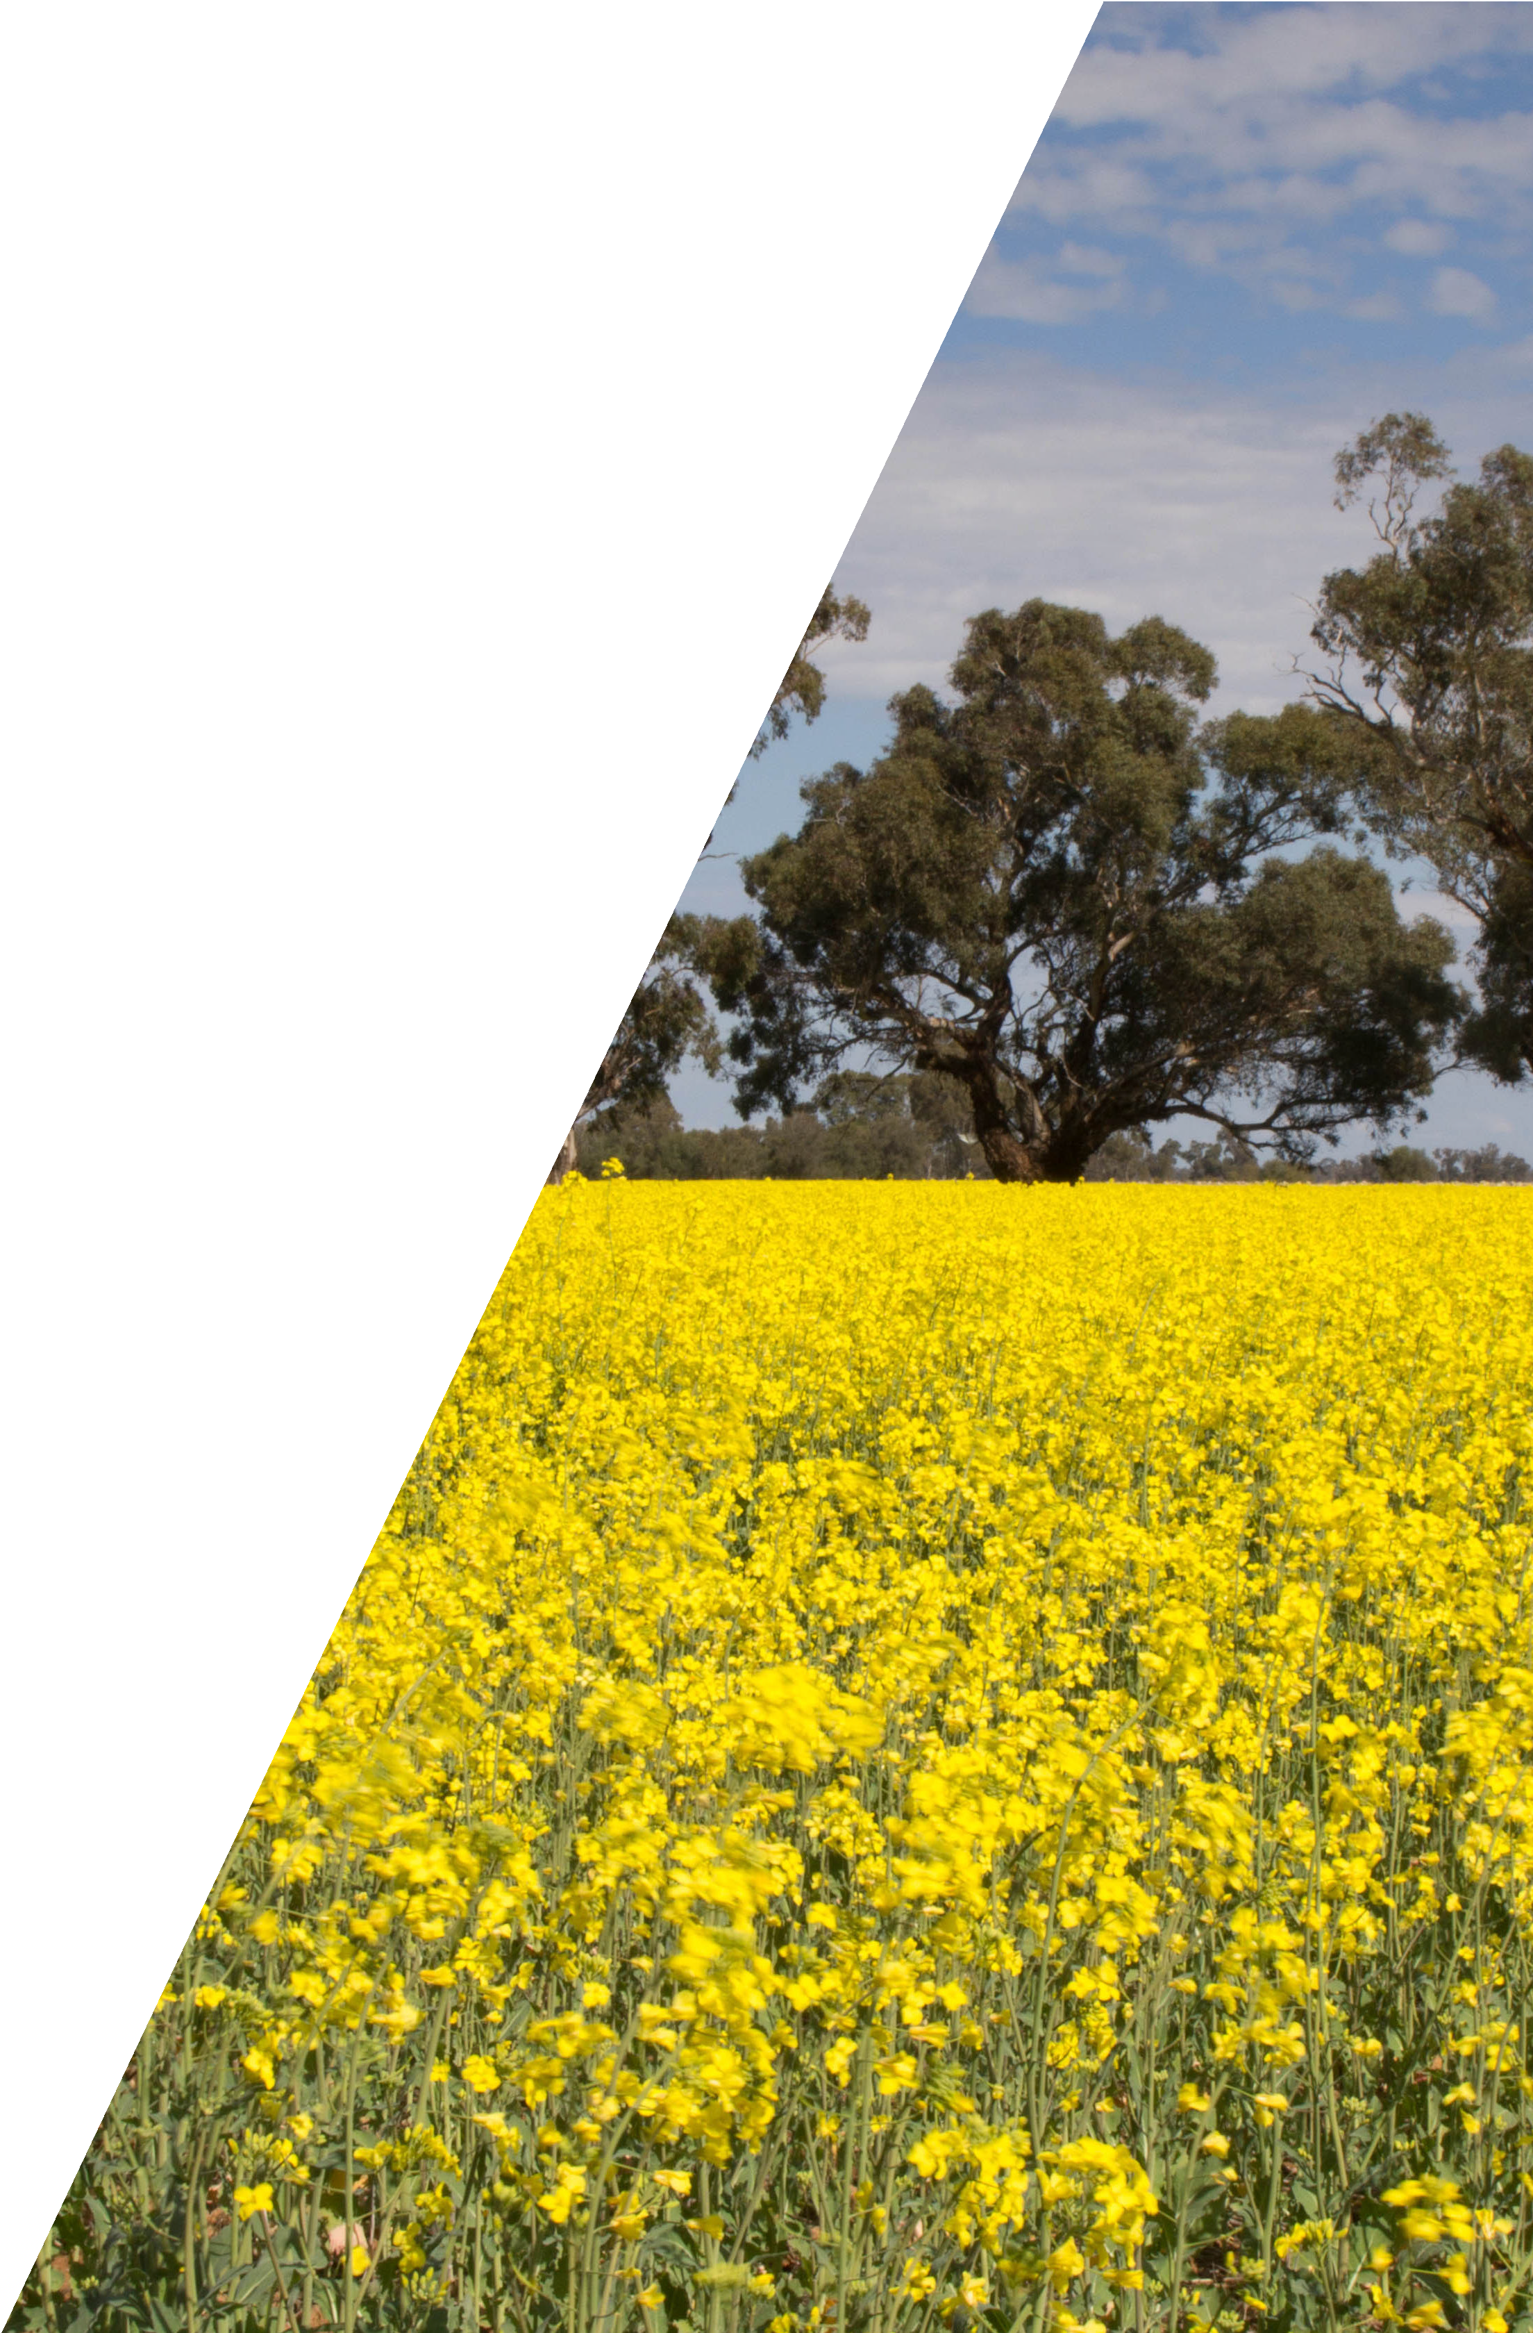

Information that must be supplied in an ATCW application
The ATCW application form contains 12 sections, which collect information about the applicant (sections 1 through to 6), the land where the applicant plans to control wildlife (section 7), and seeks detailed information in relation to the wildlife requiring control including:
- the species and number of wildlife (based on a count or the applicant’s best estimate) that is causing the problem (section 8)
- the type and extent of damage caused by wildlife (section 9)
- what management actions the applicant has attempted to manage the wildlife problem that do not require an ATCW (i.e. actions that are not scaring, harassing, chasing or lethal control) (section 10)
- what activities the applicant is proposing to undertake to manage the wildlife problem (e.g. scaring, shooting, trapping and shooting, trapping and release, destroying eggs and nests) (section 11).
The final section (12) requires the applicant to sign an acknowledgement that providing false or misleading information is an offence and a statement that information provided in the application for the ATCW is true and correct.

What we have heard so far

DELWP is already aware of some concerns that stakeholders have raised about the ATCW application process. These are listed here, along with information on actions that DELWP has taken, or DELWP’s position regarding the concern.

Table 1: Key concerns raised by stakeholders about the ATCW application process

Concerns raised by stakeholders | DELWP update or response
1.1 Prospective applicants have said that there is not much guidance available on how to apply for an ATCW | DELWP has progressively added guidance and information onto a dedicated website. Regional staff and the Customer Contact Centre are also able to provide additional information if people prefer a different channel of communication.
1.2 Some applicants consider that the information requirements during the application process are too onerous | Interfering with or controlling wildlife is a serious matter and an ATCW can only be issued if the delegate is satisfied that it is necessary. To establish this, a number of criteria must be considered, these are listed in Theme 2 on page 11. DELWP is constantly updating and improving extension materials to assist applicants to respond to information requirements, but it cannot waive these.
1.3 Stakeholders have raised concerns about the difficulty of accurately and reliably estimating the number of wildlife causing damage | DELWP is working with research institutions and wildlife experts to evaluate methods of assessing damage caused by overabundant wildlife and options for humane control methods (both lethal, non-lethal, or combination thereof).
1.4 Some stakeholders would like to know what kind of evidence DELWP requires from applicants to show control is necessary | The evidence required differs depending on the reason for which an application has been submitted and the method of control proposed. For instance, where human safety is at risk due to kangaroos behaving aggressively towards people, wildlife officers will generally inspect the site to verify the report before issuing an ATCW for lethal control. On the other hand, where ducks are fouling produce, photographic evidence of the damage caused may be all that is required.  In some circumstances, it may be difficult to obtain direct evidence of damage and it may therefore be necessary to include proxy evidence to verify impacts. Take the example where a farmer is losing income because kangaroos compete with their livestock for feed. It is difficult to observe the kangaroos in the act of browsing as they are mostly active at night, so it may be necessary to use a combination of proxy evidence such as droppings and photographs of fence damage to verify impacts. The assessment guidelines used by Forest and Wildlife Officers contain examples of typical damage for different species for reference.
1.5 Some applicants have provided feedback that processing time for ATCW applications is too long | On average, assessment of an applications takes between  4 to 6 weeks. However, there is considerable variability in the processing time depending on the risk and complexity of the application. Some applications are processed in less than  2 weeks, other may take longer than 6 weeks, especially if input from DELWP’s Independent Panel of Experts is required.

Concerns raised by stakeholders | DELWP update or response
1.6 Some stakeholders feel that applicants should be required to undertake firearms accuracy training and testing to ensure lethal control is humane | DELWP agrees that lethal control of wildlife must be humane and places specific conditions on ATCWs for lethal control that stipulate how control is to be undertaken to ensure it is humane.  However, the ability to shoot accurately does not guarantee the most humane death of an animal. Shooting occurs in a natural, dynamic setting, in which it is impossible to control all variables all of the time. For example, wind variability and unpredictable animal movement can both significantly influence shot accuracy. This means that even an outstanding marksman will, at times, not land a perfect shot. The conditions included on an ATCW for lethal control are in place to maximise the likelihood of an immediate, humane death of the target animal. They also prescribe the process that must be followed in case an animal is injured in the process, to ensure humane practices are followed if a mistake is made.  Requiring accuracy tests for all shooters may therefore not result in reduced occurrence of body shots.  The Firearms Act 1996 (Firearms Act), which regulates firearms matters is administered by Victoria Police. The Wildlife Act does not stipulate that an ATCW holder must have attained a certain level of shooting proficiency and the National Code of Practice for the Humane Shooting of Kangaroos and Wallabies for  Non-commercial Purposes (Commonwealth of Australia 2008) also does not include competency requirements.  It is also important to consider that firearms accuracy tests are not required for similar permit systems in other states, people shooting pest species, hunters, or for wildlife rehabilitators who euthanise wildlife with a firearm.
1.7 Some stakeholders who experience persistent wildlife impacts say that re-applying for an ATCW is too onerous and required too frequently | DELWP understands that in some areas wildlife impacts continue to be felt over many years, and the Wildlife Act does provide for renewal of ATCWs. However, DELWP does not currently allow renewals of ATCWs because if wildlife impacts persist beyond the lifespan of an ATCW, which is usually 1 year, then it is timely to carefully assess whether the authorised control is appropriate, or whether alternative approaches should be considered.  It may also be more appropriate to prepare a wildlife management plan for a particular ongoing wildlife problem (e. g. airports where bird strike may need to be managed on a seasonal basis as birds migrate between habitats). ATCWs supporting a recognised wildlife management plan may be issued for up to 3 years.
1.8 People do not know about the ATCW system and inadvertently undertake control activities, which are illegal without authorisation | DELWP sometimes receives anecdotal evidence about unauthorised control activities being undertaken by a landholder. DELWP will follow up such reports, where sufficient information is available to locate the landholder, and will educate them about the legislation regarding wildlife. If culpability is established, DELWP will charge the person for an offence under the Wildlife Act.  DELWP also routinely posts media releases and other news items to its website to alert the community about their responsibilities in regard to the protection of wildlife.

Ideas for improvement

This section describes some potential solutions to concerns raised previously by the community and invites you to provide your feedback on these solutions.

Suggested improvement to concern 1.5

ATCWs are not issued fast enough
DELWP could allow applicants to apply for an ATCW pro-actively, provided they can substantiate a claim that damage previously experienced is likely to
re-occur (e. g. due to seasonal migration of wildlife, crop ripening, planting season) and that a detailed Wildlife Management Plan, which includes non-lethal methods for control of wildlife, is submitted and accepted by DELWP.

Suggested improvement to concern 1.7

Simplifying the renewal or re-application process
DELWP could amend the ATCW system to introduce a streamlined process for renewing an existing authorisation or applying for a subsequent ATCW. However, it is considered that this would only result in minor reduction in administration burden to the applicant, as the process would need to ensure that rigour is maintained and would likely incorporate an inspection schedule or a similar means to verify appropriateness of re-issuing or renewing an ATCW.

Question 1.2 Do you support the suggestion that DELWP should allow applicants to apply for an ATCW pro-actively (i.e. before the damage occurs) in situations where damage is likely to reoccur (e.g. seasonal damage to fruit crops by birds)?
Question 1.3 Do you support the suggestion that DELWP should introduce a streamlined renewal process for ATCWs?
Question 1.4 Do you support the suggestion that all shooters, regardless of target species, should be required to pass a shooting proficiency test?
Question 1.5 What else could DELWP do to improve the ATCW application process?
Do you have any concerns with the ATCW application process that were not identified in the discussion paper?
Question 1.1
Questions

Theme 2: Decision making

When assessing an ATCW application, DELWP officers follow internal guidelines which set out key criteria that must be considered in the decision- making process. DELWP is in the process of updating these ATCW assessment and decision- making guidelines for DELWP staff, they will incorporate wildlife and agricultural expertise and advances in scientific knowledge about sustainable wildlife management. The final revised protocols will be adopted state-wide to assist with consistent decision making throughout the state.
This theme explains the current assessment and decision-making process that is followed and goes on to discuss concerns raised previously by the community and then presents some ideas for how these concerns could be addressed.

Assessment of ATCW applications
When an ATCW application is received, it is assigned to a regional DELWP Forest and Wildlife Officer, who verifies personal and property data and assesses the information provided to determine if the requirements under section 28A of the Wildlife Act are met. That is, they will assess whether the control method(s) requested in the ATCW application can be authorised and are necessary:
- because wildlife is damaging a building, vineyard, orchard, crop, tree, pasture, habitat or other property
- for the management, conservation, protection or control of wildlife (e.g. where wildlife are impacting on biodiversity values)
- to ensure the health or safety of people, or
- to support a recognised wildlife management plan.

What is involved in assessing ATCW applications
Assessment of the application will include some or all the following steps, depending on the complexity and the risk associated with the application: a quality assurance check, desktop assessment, phone interview and property inspection.

Quality Assurance check
Upon receipt of an application it is subjected to an initial quality assurance check to determine if the application is complete and can be accepted. If there are major information gaps then an application will be rejected.

Desktop Assessment
Where an application is complete or has only minor shortcomings it will be accepted and progressed to a desktop assessment. At this stage, an officer will determine if the requirements of the Wildlife Act are met, and if sufficient information is provided to enable an ATCW to be issued. This scenario is most likely for low risk ATCW applications, such as using a gas gun to frighten birds from an orchard.

Seeking more information via phone interview or site inspection
For applications where the officer feels they require additional information to be able to provide the delegate with a recommendation as to whether or not an ATCW should be issued, the next step is either a phone interview, a property inspection, or both.
During the phone interview, the officer will seek further clarification about the information provided in the application to gain an understanding of the wildlife issue, the property and the methods already trialled to manage the situation. The officer will also gauge the level of understanding the applicant has about the applicable legislation, permit requirements and so on, and provide advice as appropriate.
DELWP cannot inspect every property for which an ATCW application is received. Instead, DELWP prioritises inspections of properties of first time applicants and of high risk applications.

First time applicants are visited to give assessing officers the opportunity to familiarise themselves with the particular wildlife problem at the property, and to educate the applicant about wildlife ecology, legal requirements, ATCW conditions and species- specific control methods.
High risk applications are prioritised for inspection to ensure that regulatory oversight and the evidentiary requirements are appropriate for the risk inherent in the application. The risk of an application is determined by considering factors such as the type of control being applied for, the species and number of individuals to be controlled. Examples of applications that would be considered high risk are applications to control a large number of animals, or where the method of control poses a risk to the public (e.g. shooting near a busy road). A low risk example would be an application for use of a gas gun to protect orchard fruit from birds.
The fact that many species of Australian wildlife are most active during the night or at dawn and dusk is very challenging to DELWP, which not only administers the ATCW system, but is also an employer and must ensure the safety and well-being of staff. Inspections are therefore generally undertaken during the day.

Did you know?
DELWP recently commissioned a state- wide kangaroo survey to better understand the current distribution of kangaroos in the state. Eastern Grey Kangaroos are the species most commonly controlled in Victoria. The results will be used to ensure that authorised kangaroo control will not impact on the sustainability of Victorian kangaroo populations.
More information about the kangaroo survey is available on the DELWP website at: www.wildlife.vic.gov.au/our-wildlife/ kangaroos

What we consider when assessing an ATCW application
In assessing an ATCW application, the following criteria will be considered:
- How severe is the wildlife problem? (e.g. the extent of property damage or level of threat presented to human safety)
- What is the underlying cause of the problem?
- What non-lethal management methods that do not require an ATCW are available and have these methods been sufficiently explored by the applicant?
- Are other methods available for resolving the problem?
- What is the local and broader environmental context (i.e. has there been a bushfire in the region? Is the area drought affected?)
- Would the proposed action have a detrimental effect on the conservation status of the species or the environment?
- Is the wildlife problem so complex that the application should be referred to the Independent Panel of Experts for advice? (Note: more information on the Independent Panel of Experts can be found on page 15).
- Is lethal control the most effective method of reducing the damage and is it appropriate (i.e. for the species of wildlife requested and in the area in which the control is to occur)?
- Will an integrated approach (using non-lethal and lethal methods) provide a better outcome, and if so, is the applicant willing to amend the ATCW application accordingly?
- What is the lowest number of animals that can be controlled to achieve the objectives?
If assessment of the application against these criteria leaves either the assessing officer or the delegate responsible for approving the ATCW unconvinced that wildlife control is necessary, then an application will not be successful.
The next section describes in more detail some of the key considerations from the list above that officers take into account when assessing ATCW applications.

Have all practical non-lethal methods been attempted?
What is impractical?
Impractical is defined as those methods that are too costly to implement. In other words, the cost of implementing the control method is greater than the cost of the wildlife problem or beyond the means of the impacted landholder. Assessing officers need to exercise discretion in the determination of whether all practical methods have been trialled.
For example, installing kangaroo-proof fencing around even a relatively small property may well exceed the financial capacity of a struggling landholder and therefore would be an impractical method in this scenario. Conversely, to a thriving agri-business the cost of putting up netting on large orchards, or fencing broad acre farms may be acceptable and would therefore represent a practical control method.
Also included in the definition of impractical are methods that are counter- productive, such as erecting an electric fence around a property in a high fire risk area, as are those methods that cost a large amount of time (e.g. active scaring) and distract the landholder from their core business.
Establishing whether non-lethal control methods have been considered is a key step of the assessment process. If it is unclear from the application, assessing officers will contact applicants to establish if non-lethal methods have been trialled and will also use this opportunity to provide information about available control methods appropriate for the species subject to control. Officers only assess ATCW applications for lethal control when non-lethal methods are proven to be ineffective, are impractical to implement, or pose significant risks to animal welfare.
It is important to note that some non-lethal control methods are cost-prohibitive or not practical at certain scales. In these cases, it is not reasonable to demand applicants to use these control methods. Likewise, some non-lethal control methods, such as fertility control for kangaroos, can represent a less humane option as these animals are likely to develop capture myopathy due to the stress of capture and handling, which often results in death. Fertility control is also problematic because it takes several years before the population will reduce in number. This option is usually not acceptable for a land holder who is currently experiencing impacts from wildlife.
DELWP routinely updates and publishes materials about wildlife management methods, including non-lethal control options, on its website and officers will provide applicants with extension materials as appropriate.
An example is the recent publication of Guidelines for Reducing Cockatoo Damage, which equips readers with guidance on how to mitigate impacts from these bird species in a variety of situations.
It incorporates advice from wildlife experts about the most efficient and humane combination of non-lethal and lethal control for these birds.

How we verify damage
During the assessment process, wildlife officers will determine if the damage is being caused by the species claimed on the application by assessing whether the description of the damage is consistent for the species. Some impacts are easily verifiable, for example damage to fences from kangaroos or wombats, fouling of vegetables from ducks, or bite marks on fruit from lorikeets or flying foxes. In other cases, further investigation may be required to determine the cause of the damage. For instance, pest species or erosion could be causing the problem. Assessing officers will follow up with the applicant as appropriate either through a site visit or a phone interview.

The standard we use when assessing carrying capacity and damage from kangaroos
Explaining the Dry Sheep Equivalent Standard
The Dry Sheep Equivalent (DSE) is the accepted approach to compare the feed requirements of different classes of livestock and to assess the carrying capacity of a particular parcel of land.
The unit represents the amount of feed required by a two-year-old, 45 kg Merino sheep to maintain its weight. This means that a 45 kg sheep has a DSE rating of 1, and animals requiring more feed have a higher rating, and animals requiring less feed have a lower rating.
It is important to note that DSE ratings are based on a number of assumptions about weights, growth rates and lambing percentages. There will be some variation in these figures from region to region and from farm to farm. As such, the figures used are estimates, however they give a good idea of the general differences between different animals
The carrying capacity of a paddock or farm is the number of stock expressed as DSE per hectare that can be carried through most years. In a drought, it will not be possible to maintain the potential carrying capacity, as pasture growth is often less than half of the usual production.
The DSE is one of the methods that DELWP may use during the ATCW assessment process to determine the carrying capacity of a property and the damage likely to be incurred by the landholder through competition of kangaroos with their livestock.
Recent research has indicated that the previously used DSE of 0.6 for kangaroos overestimates the feed requirements of kangaroos and that a DSE of 0.4 is more appropriate. DELWP has recently updated the DSE for kangaroos in the ATCW assessment and decision-making guidelines for DELWP staff to reflect this finding.

How we determine the period an ATCW is issued for
The Wildlife Act allows for authorisations to be valid for a period of up to 3 years. However, in most cases, ATCWs for lethal control are issued for a period of 12 months. The reason for this is that staggering the shooting of wildlife over a 12-month period means a smaller number of animals are killed per shooting event. Each shooting event also acts as a deterrent to the rest of the group, as animals will disperse during shooting and learn to associate the site with danger.

ATCW conditions
All ATCWs include conditions that prescribe the circumstances under which the authorised person has the authority to undertake the control activity. This includes the control method, location that control can be undertaken, number of animals that can be controlled and the duration of the ATCW.
ATCWs also include a set of conditions designed to ensure that animal welfare is protected. There are several different types of ATCW (e.g. disturb, destroy, take and disturb etc.) and there are standard conditions for each type. Officers may also add additional conditions to ATCWs where necessary, for example to mandate time of control (e.g. only on certain days) or requiring that shooting must be directed away from a sensitive area (e.g. not in the direction of a busy highway). More information on ATCW conditions is provided in Theme 3: Compliance Monitoring and Enforcement.

How we assess ATCWs that include a wildlife management plan
The ATCW system is an administrative system set up to support section 28A of the Wildlife Act. Benchmarking the ATCW system against best practice regulatory principles is thus voluntary as it does not have the same standing as statutory policy or regulation.

*Note: the aim of this characteristic is to provide transparent mechanisms for regulated parties to appeal against regulatory decisions that may have significant impacts on businesses or individuals.
Subject to appeal*
Proportional
Flexible
Co-operative
Effective
Transparent Consistent
and predictable
Accountable
Best Practice Regulatory Principles
DELWP is committed to best practice principles in regulatory design and policy. The Victorian Guide to Regulation, Toolkit 1, Purposes and types of regulation states that good regulatory systems are:
Both public and private land managers, such as Parks Victoria, Water Authorities or property developers sometimes apply for ATCWs that are based on a wildlife management plan. Under the Wildlife Act, the plan must have been reviewed and approved by DELWP for the ATCW to be issued.
Wildlife management plans are comprehensive documents which consider the options available to address a wildlife problem in a systematic manner and over an extended period of time. ATCW applications that include a wildlife management plan are usually complex, specify a large number of animals to be controlled, involve several species and cover large areas. Scrutiny of such applications is consequently of very high rigour and often involves incorporation of specific advice from the Independent Panel of Experts.
The Independent Panel of Experts
DELWP has an Independent Panel of Experts (IPE) which reviews and provides advice on complex ATCW applications or wildlife management matters. The recommendations by the IPE are non- binding, meaning that DELWP will consider IPE recommendations when making a decision about an ATCW application or issue, but is not bound by them.
Panel members have expertise in a range of areas including wildlife management, animal welfare, veterinary science, planning and community engagement, and public policy.

DELWP seeks to administer the ATCW system in line with best practice regulatory principles, one of which is That regulation should be proportional. DELWP therefore needs to carefully balance setting conditions so that they are strict enough to ensure that control is undertaken humanely, yet do not result in undue regulatory burden.

What we have heard so far

DELWP is already aware of some concerns that stakeholders have raised about the ATCW decision making process. These are listed in Table 2.1, along with information on actions that DELWP has taken, or DELWP’s position regarding the concern.

Table 2.1: Concerns raised by stakeholders about the ATCW decision making process

Concerns raised by stakeholders | DELWP update or response
2.1 Does the maximum number of animals that can be controlled under a permit relate to independent adult animals only, or include pouch young or young at foot? If pouch young or young at foot are included, then they must be specified in the total number. | The question relates to situations where a landholder accidentally kills an animal with dependent young (including young at foot for kangaroos or wallabies). ATCW conditions stipulate that the shooter must then take all reasonable efforts to humanely kill those young.  DELWP’s current practice is to count young at foot as part of the allocated number that the land owner is authorised to control.  Pouch young are not counted.
2.2 Assessing officers are not equipped with the necessary knowledge and understanding of wildlife (e.g. kangaroos). | When DELWP recruits Forest and Wildlife Officers it seeks out individuals with tertiary qualifications or significant experience in wildlife ecology, zoology, natural resource management, environmental management or similar natural sciences. Forest and Wildlife Officers receive extensive on the job training in wildlife matters, and the ATCW assessment and decision-making guidelines also include species specific information to assist officers assess applications. Authorised Officer training equips officers with comprehensive understanding of the  relevant legislation.  Junior officers are routinely paired up with more senior and experienced officers for mentoring and knowledge transfer.
2.3 Officers do not have the requisite agricultural expertise needed for assessing an application. | DELWP Forest and Wildlife Officers receive training in agricultural practice. The ATCW assessment and decision- making guidelines also include species specific information to assist officers assessing applications. DELWP has close linkages to agriculture experts at the Department of Economic Development, Jobs, Transport and Resources and officers can seek advice from them if necessary.  Junior officers are routinely paired up with more senior, experienced officers for mentoring and knowledge transfer.
2.4 Some applicants with properties in different DELWP regions feel that there are regional differences in ATCW assessments, especially regarding the number of animals they are permitted to control on comparable properties. | The ATCW system is administered through a manual wildlife licensing system and whilst the guidance materials currently used by assessing officers are the same across the state, there is scope for regional variation. As mentioned earlier in this theme, DELWP is in the process of updating the ATCW assessment and decision-making guidelines and is also planning to roll out a new online wildlife licensing system (OWLS) in mid-2018. Both initiatives will drive increased consistency in ATCW assessment and administration across the state.

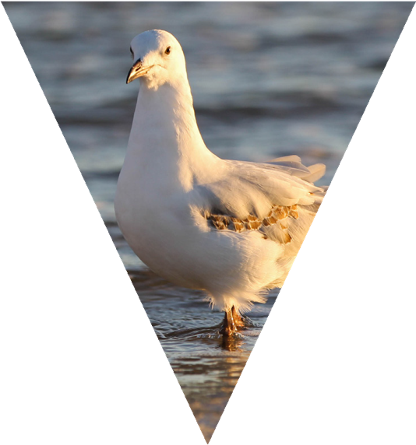

Questions
Question 2.1 Do you have any concerns with the ATCW decision making process that were not identified in the discussion paper?
Question 2.2 The Wildlife Act does not define a minimum threshold that damage must exceed before a land owner/manager may apply for an ATCW. Do you support the suggestion to introduce a minimum damage threshold?
If you answered yes to the question above, do you have any suggestions for how DELWP could determine the minimum level of damage that must be experienced before an ATCW can be applied for?
Question 2.3 Some other Australian states provide a damage estimate calculator for land owners/ managers that uses modelling to estimate damage caused by wildlife. Do you think a tool like this would be useful for Victoria?
Question 2.4 What else could DELWP do to improve the ATCW decision making process?

Theme 3: Compliance Monitoring and Enforcement

Compliance monitoring and enforcement activities are a vital part of any regulatory system. Early engagement with stakeholders about the ATCW system identified that the way DELWP undertakes compliance monitoring and responds to instances of non-compliance is one of the most important issues for some stakeholder groups.
This theme explains how DELWP currently undertakes compliance monitoring and responds to instances of non-compliance with the ATCW system, outlines some of the specific concerns stakeholders have raised with the current approach, provides some possible solutions for these concerns and asks for your suggestions on how else this could be improved.

DELWP’s compliance approach
DELWP applies a risk-based, intelligence-led compliance approach and uses a range of compliance activities to encourage compliance and deter non-compliance. The activities undertaken to achieve compliance are selected based on a risk assessment, with consideration being given to the cost and benefit of different compliance activities and the risk posed by the non-compliance.
DELWP focuses compliance activities on areas where the relative risks associated with non- compliance are greatest. This does not mean that low risk non-compliances, such as not complying
with the carcass disposal requirements of an ATCW, are neglected. Rather, the tools used in these areas are less time and resource intensive, allowing DELWP to direct a larger proportion of resources to high risk non-compliances.
For example, activities that may impact on the sustainability of wildlife populations, such as shooting wildlife without authorisation, or someone controlling more wildlife than they are authorised to control, are considered high risk and are therefore a focus for DELWP’s compliance activities.
Compliance activities fall into one of three categories, which are outlined in Table 3.1.

ATCW conditions
Authorisations issued under the ATCW system are subject to enforceable conditions, which are requirements that the holder of the ATCW must comply with when acting on the authorisation. The conditions of ATCWs vary, depending on the species, method(s) of control and other relevant factors for the individual ATCW.
The Prevention of Cruelty to Animals Act 1986 (POCTA) does not apply to activities conducted in accordance with licences, authorisations and permits issued under the Wildlife Act1. This means that DELWP must ensure that written authorisations

1 Except for Part 3 of POCTA — Scientific Procedures.

Table 3.1 Compliance activity examples

Type of compliance activity | Examples
Encouraging compliance | - Education  - Providing information and support  - Providing incentives for compliance  - Controls, such as licence and authorisation conditions
Monitoring compliance | - Desktop assessments  - Information and intelligence gathering and assessment  - Audits  - Inspections (random or targeted)
Responding to non-compliance | - Enforcing the law  - Investigating suspected breaches of the law  - Official warnings or notices to comply  - Formal prosecution

issued under section 28A of the Wildlife Act include conditions, limitations and restrictions that prevent animal cruelty and protect animal welfare.
The conditions of ATCWs mainly relate to ensuring that the control is undertaken in a humane manner and specify things like method of control and, if a firearm is to be used, the minimum calibre. For example, in order to ensure that the control is humane, ATCWs issued for the lethal control of kangaroos include specific conditions that are based on the requirements of the National Code of Practice for the Humane Shooting of Kangaroos and Wallabies for Non-commercial Purposes (Commonwealth of Australia 2008).

How DELWP encourages compliance
Example conditions from an ATCW to trap and release wildlife
- You must only use the approved trap listed on this authorisation.
- You must release all animals trapped under this authorisation at a location specified by an authorised wildlife officer of the Department of Environment, Land, Water and Planning.
- You must place traps in an area so that the trapped animal is protected from full sunlight, rain and extreme cold or
hot conditions.
- For nocturnal animals, you must check the traps no later than two hours
after sunrise.
- For diurnal animals, you must check the traps at intervals not exceeding
two hours.
- You must not hold animals you trap for longer than 24 hours.
- You must provide a copy of this authorisation on demand to an authorised officer of the Department of Environment, Land, Water and Planning.
DELWP encourages and supports voluntary compliance by assisting the community to understand how to comply with the ATCW system, to increase the community’s capacity and willingness to comply.
DELWP does this by providing information about the ATCW system on the website, on the application form, through the Customer Contact Centre and through extension activities undertaken by DELWP Forest and Wildlife Officers.

How DELWP monitors compliance
DELWP has Forest and Wildlife Officers located in every DELWP region who are responsible for monitoring and responding to non-compliance with the Wildlife Act and Wildlife Regulations. The Forest and Wildlife Officers are ‘Authorised Officers’ under the Conservation, Forests and Lands Act 1987 for the purposes of the Wildlife Act.
Under the Wildlife Act, Authorised Officers have the power to:
- Enter, inspect or search any property and any buildings or structures other than a dwelling, as well as vehicles or boats for the purposes of the Wildlife Act, with or without notice.
- Inspect any parcel, bag or receptacle the officer reasonably believes either is being used or is likely to be used in contravention of the Act (e.g. a cardboard box they believe holds wildlife; a hunter’s bags or esky).
- Investigate reports of alleged illegal activity relating to wildlife.
- Require that a person produces their licence under the Firearms Act to possess, carry or use a firearm in their possession.
- To enter any part of a premises used only for residential purposes, an Authorised Officer must have permission of the occupier or another person who apparently represents the occupier.
DELWP Forest and Wildlife Officers monitor compliance with the ATCW system and investigate reports of non-compliance made by the public.

Important information about evidence
DELWP is bound by the Evidence Act 2008 (Vic) (Evidence Act) in prosecuting non-compliance with the Wildlife Act and therefore the ATCW system. The Evidence Act sets out the rules of evidence, that is, what types of evidence can be used and in what circumstances to achieve a successful prosecution.
While some reports of non-compliance received from the public will be able to be substantiated and lead to charges being laid, in many cases, reports of non-compliance made by the public will not be able to be substantiated with sufficient evidence to clearly establish that non-compliance has occurred, and by whom.

How DELWP responds to non-compliance
How you can help
If you suspect someone is engaging in wildlife crime, you can report it to DELWP's Customer Contact Centre on 136 186 or to Crime Stoppers 1800 333 000.
If non-compliance with the ATCW system is detected, it is addressed through a regulatory response that is proportionate to the degree and the risk posed by the non-compliance, and takes into account the culpability of the offender. That is, it considers whether the offender committed the act intentionally, knew the act was illegal and can’t provide a justification for the act. DELWP’s compliance response is limited by the penalty provisions available in the Wildlife Act and Wildlife Regulations for the offence.
There are a number of offences under the Wildlife Act and Wildlife Regulations that are relevant to the ATCW system. Table 3.2 shows the relevant offences and the maximum penalty that could apply under the Wildlife Act or Wildlife Regulations.

Table 3.2 Offences and penalties under the Wildlife Act and Wildlife Regulations

Offence | Maximum penalty | 2017/18 penalty unit amount*
Hunt, take or destroy threatened wildlife without an authorisation | 240 penalty units or 24 months imprisonment, or both; and  20 penalty units per head of wildlife | $38,056.80  $3,171.40 per head of wildlife
Hunt, take or destroy threatened wildlife without an authorisation | 50 penalty units or 6 months imprisonment, or both; and  5 penalty units per head of wildlife | $7,928.50  $792.85 per head of wildlife
Failure to comply with the conditions of an authorisation | 50 penalty units | $7,928.50
Use of prohibited equipment (e.g. traps) without an authorisation | 25 penalty units | $3,964.25
Use of poisons without an authorisation | 100 penalty units or 6 months imprisonment | $15,857
Disturbing protected wildlife without an authorisation | 20 penalty units | $3,171.40
Providing false information in connection with an application for an authorisation | 120 penalty units | $19,028.40
Using a gun, bow or other weapon to take wildlife without an authorisation | 50 penalty units | $7,928.50
Using a firearm from a motor vehicle, boat or other vehicle in order to take wildlife, without an authorisation | 50 penalty units | $7,928.50
*The value of a penalty unit is set by the Department of Treasury and Finance and is updated on July 1 each year. The current value of a penalty unit is $158.57 (as at July 2017).

Offences under POCTA
POCTA is the primary legislation in Victoria to ensure the humane treatment of animals, including wildlife. POCTA is administered by the Department of Economic Development, Jobs, Transport and Resources. Forest and Wildlife Officers are also authorised under POCTA and can therefore investigate and respond to allegations of animal cruelty.
Activities conducted in accordance with an authorisation issued under the Wildlife Act are exempt from the requirements of POCTA. This means that, provided that an ATCW holder is complying with the conditions of the ATCW, they are not committing an offence under POCTA when carrying out the control of wildlife. However, if the conditions of an ATCW are breached, then they may be committing an offence under POCTA when carrying out the control.

Compliance response options
Did you know?
The penalty for acts of cruelty under POCTA is up to 250 penalty units ($39,642.50) for a natural person or 12 months imprisonment, or up to 600 penalty units ($95,142) for a body corporate.
The penalty for acts of aggravated cruelty which results in death or disablement of an animal is up to 500 penalty units ($79,285) or 2 years imprisonment for a person, or up to 1200 penalty units ($190,284) for a body corporate.
The following compliance response options are available to DELWP:
- Provide education and guidance on the compliance obligations, the negative impacts of non-compliance and the best practice ways of complying.
- Issue an official written warning.
- Request that voluntary corrective action is undertaken to address non-compliance, if request for corrective action is ignored then compliance action can be escalated.
- Impose additional conditions or restrictions on an authorisation.
- Refuse to grant or renew an authorisation.
- Suspend an authorisation (for a period of up to 90 days).
- Cancel an authorisation.
- Initiate prosecution proceedings, officers will prepare a formal brief of evidence and a magistrate can then decide on a range of penalties up to the set maximum, if the person is found guilty.

Examples of proportionate, risk-based responses to non-compliance
If an ATCW holder did not comply with a condition requiring that carcasses from lethal control were buried, but the accused was proactive in attempts to address the non-compliance, then DELWP would be likely to respond by providing education and guidance on the compliance obligations, the negative impacts of non- compliance and the best practice ways of complying.
However, if DELWP suspected that someone has deliberately shot protected wildlife without authorisation, then DELWP would be likely to respond by initiating prosecution for a fine and/or imprisonment.

Other relevant factors
When determining the compliance response, in addition to considering the risk of the offence, DELWP Forest and Wildlife Officers also consider the following:
- Compliance history of accused — whether they have been charged for previous offences under relevant legislation (e.g. Wildlife Act, POCTA).
- Culpability of the accused — whether the non- compliance was deliberate or unintentional.
- Degree of proactivity of the accused — whether there were proactive attempts to avoid non- compliance, self-reporting non-compliance, proactive attempts to address non-compliance or to limit future non-compliance.

What we’ve heard so far

DELWP has already heard a number of concerns and suggestions raised by stakeholders about the way DELWP monitors and responds to non- compliance with the ATCW system, these are provided in Table 3.3.
While DELWP agrees that the suggestions made by stakeholders in Table 3.3 would address the issues raised, there are important considerations and limitations relating to some of the suggestions that will need to be taken into consideration when developing the final recommendations to improve the system. The third column of the table outlines these important considerations and limitations.

Table 3.3 Specific concerns and suggestions raised by stakeholders so far

Concern raised by stakeholders | Suggestion by stakeholders of how to address the issue | DELWP update or response
3.1 DELWP does not know how many animals are actually controlled under an ATCW | Authorisation holders should be required to submit returns reporting on number of animals controlled | ATCW holders were previously required to submit returns, however this requirement was removed to reduce administrative burden.  While it may be timely to re-consider this requirement, it is likely to receive criticism from users of the ATCW system and some stakeholder groups.  If returns were to be re-introduced, the new online wildlife licencing system, OWLS, will have an electronic record keeping and reporting function for licence holders, which would streamline the reporting process. This would result in a reduction in the administrative burden compared to being required to complete manual returns.
3.2 DELWP does not know whether authorisation holders are complying with the conditions of their ATCW | DELWP should undertake follow-up inspections to check compliance with the conditions of ATCWs when control is being undertaken | While DELWP does investigate all reports of non-compliance with the ATCW system, this activity is considered high risk for staff if the ATCW is for lethal control with a firearm. As a result, DELWP’s employee safety policy requires that a minimum of two DELWP staff and officers from Victoria Police attend these types of investigations.  As pro-active inspections would need to be undertaken at night, as that is when most ATCWs for lethal control would be acted upon, the requirement for a minimum of two DELWP staff and Victoria Police assistance would also apply. As a result, undertaking pro-active inspections to check compliance with ATCWs for lethal control with a firearm would be very costly and resource intensive for both DELWP and Victoria Police.
3.3 Agents acting under a landholder’s ATCW do not understand the conditions of  the ATCW | DELWP should require that agents are listed on the application form and must sign a declaration stating that they have read and understood the conditions | Listing agents on application form was also previously required but was removed to reduce administrative burden. While it may be timely to re-consider this requirement, it is likely to receive criticism from users of the ATCW system and some stakeholder groups.

Ideas for improvements

Based on the stakeholder feedback received so far and consideration of the way similar systems are regulated in other states, DELWP has come up with some additional ideas for how the ATCW system could be improved.

Improving the range of sanctions available
Best practice regulatory frameworks include a hierarchy of enforcement tools that enable a graduated response, depending on the non- compliance and culpability. One of the main gaps in DELWP’s ability to effectively enforce compliance with the ATCW system is the lack of a range of sanctions available under the Wildlife Act.
If the range of sanctions was improved, it would allow a more proportionate response to non- compliance, in line with community expectations, and would provide DELWP with less resource intensive alternatives to prosecution to address non-compliances with the ATCW system.
One example of a sanction that could be introduced is Penalty Infringement Notices (PINs). Introducing PINs would allow DELWP to issue on the spot fines for non-compliance.
PINs are widely used (e.g. for parking and traffic offences) and allow the regulator to promptly take action for a non-compliance, rather than initiating a case for prosecution, which is a lengthy and resource intensive process. It would also mean that the undesirable behaviour and the punishment are more closely linked, which may therefore have a greater impact on behaviour change and act as a deterrent.

Governor in Council (GIC) Orders allowing disturbance of common wildlife species without authorisation
Under the Wildlife Act, GIC Orders can be put in place to unprotect particular species of wildlife in certain circumstances from certain activities (see the ‘Did you know’ box on page 4 for more information). In order to streamline DELWP’s compliance and enforcement activities and allow a greater focus on high risk non-compliances, DELWP could put in place GIC Orders allowing disturbance of common wildlife species, such as Eastern Grey Kangaroos and
Musk Lorikeets, without authorisation. The GIC Order would specify where and how the control could be undertaken, for example scaring Musk Lorikeets away from orchards using Bird Frite cartridges.

Question 3.2 Do you support the suggestion that ATCW holders should be required to submit returns to DELWP which state how many animals were controlled under the ATCW?
Question 3.3 Do you support the suggestion that agents (people who may undertake the control that are not the ATCW holder) should be required to be listed on the application form and authorisation?
Question 3.4 Do you support the suggestion that the range of sanctions available for use by DELWP's compliance staff should be improved?
Question 3.5 Do you support the suggestion that Governor In Council Orders should be issued to allow the disturbance (non-lethal control) of common wildlife species such as Eastern Grey Kangaroos and Musk Lorikeets, subject to conditions, without the need for individual authorisations?
Question 3.6 What else could DELWP do to improve the compliance monitoring and enforcement of the ATCW system?
Do you have any concerns with DELWP's compliance monitoring and enforcement of the ATCW system that were not included in the discussion paper?
Question 3.1
Questions

Theme 4: Traditional Owner involvement in the ATCW system

As custodians of the land, Traditional Owners and Aboriginal Victorians have managed the land and the native animals that inhabit it sustainably for thousands of generations using traditional ecological knowledge. This not only benefits their own wellbeing, but also the natural environment and the Victorian community.
The fulfillment of both Aboriginal cultural wellbeing and economic prosperity is a Victorian Government priority. Under DELWP’s Aboriginal Inclusion Plan, Munganin – Gadhaba, DELWP has committed to improving Traditional Owner access to Country and its resources, and participation in natural resource management.
Victoria’s Traditional Owner community have a strong affiliation with wildlife, and arrangements are in place to enable Traditional Owners to access wildlife for cultural purposes. The Traditional Owner Settlement Act 2010 provides for Traditional Owner corporations who have a recognition and settlement agreement with the state to enter into a Natural Resource Agreement. Natural Resource Agreements facilitate the formal involvement of Traditional Owners in land management, planning, access to and use of natural resources, including wildlife.
For Traditional Owner groups that do not have Natural Resource Agreements in place, access to wildlife for cultural purposes can be obtained through an Aboriginal cultural purposes authorisation under the Wildlife Act.
Due to the arrangements under Natural Resource Agreements and the Aboriginal cultural purposes authorisation provisions of the Wildlife Act, Traditional Owner groups do not require an ATCW to control wildlife on the land they manage.
However, to improve Traditional Owner access to and participation in natural resource management, in line with DELWP’s Aboriginal Inclusion Plan, DELWP is considering ways that Traditional Owners could be involved in the ATCW system. Some ideas that are being considered are:
- DELWP could maintain a list of Traditional Owners that are registered shooters who could be engaged by ATCW holders to undertake control work on their behalf.
- With agreement from the ATCW holder, DELWP could enable Traditional Owners to access the carcasses of wildlife controlled under an ATCW for cultural purposes.
- Partnership opportunities could be explored with Traditional Owner groups to utilise their ecological knowledge and land management skills when undertaking wildlife management activities. This could be particularly valuable for larger scale control programs that are undertaken for biodiversity conservation reasons.

Questions
Question 4.1 If you are a landholder that uses the ATCW system, would you be interested in using the services of a Traditional Owner who was on a list of DELWP registered shooters to control wildlife on your property?ing and enforcement of the ATCW system that were not included in the discussion paper?
Question 4.2 Do you support the suggestion that Traditional Owners could access wildlife controlled under ATCWs for cultural purposes? (e.g. use of skins, bones, feathers or meat).
Question 4.3 Do you have any other suggestions for ways that Traditional Owners could be involved in the control of wildlife or the ATCW system?

Theme 5: Information provision

Providing information to the community about regulatory systems is a key responsibility of a modern, transparent regulator. This theme will explain what information DELWP currently provides to the community about the ATCW system, how it is provided and the limitations to the data that can currently be provided.
The theme also outlines concerns that the community has raised so far with the current approach to information provision, provides some possible solutions for these issues and finally asks for your suggestions on how else this could be improved.

Limitations to data provision
Unfortunately, due to the limitations of DELWP’s current wildlife permit database, DELWP is unable to report on some aspects of the ATCW system. DELWP is moving to a new online wildlife licencing system in 2018 which will have a greater reporting capacity, allowing DELWP to publish additional information about the ATCW system on the website. This will improve the transparency of the ATCW system.

Table 5.1 Information channels
Current information provision arrangements
DELWP provides a range of information to the community that is relevant to the ATCW system, including:
- Wildlife Act and Wildlife Regulation requirements
- wildlife biology and ecology
- how to manage wildlife issues, including non- lethal control or deterrent methods
- the ATCW application process and requirements
- ATCW statistics, including the number of ATCWs issued, the species and number of animals authorised for control
- control that will be undertaken on public land.

For some ATCWs, DELWP notifies, or requires that the ATCW holder notifies, immediate neighbours that an ATCW has been issued in their area. This occurs where the land use on the neighbouring property means that they may be disturbed by control being undertaken, such as a horse stud, school or wildlife shelter.
Table 5.1 outlines where and how information about the ATCW system is provided.

Information provided | Information channel
Wildlife Act and Wildlife Regulation requirements | - Website  - Customer Contact Centre  - Wildlife Officers — face to face, over the phone  - ATCW application form
Wildlife biology and ecology information | - Website
How to manage wildlife problems, including suggestions for non-lethal control methods | - Website  - Customer Contact Centre  - Wildlife Officers — face to face, over the phone
ATCW application process and requirements | - Website  - Customer Contact Centre  - Wildlife Officers — face to face, over the phone  - ATCW application form
Statistics on the number of ATCWs issued, the species and number of animals authorised for control | - Website
Control that will be undertaken on public land | - Website
That an ATCW has been issued for a neighbouring property | - Wildlife Officers — face to face, over the phone or by mail  - ATCW holder — face to face, over the phone or by mail

What we’ve heard so far

DELWP has already heard a number of concerns and suggestions raised by stakeholders about the information provided by DELWP on the ATCW system, these are outlined in Table 5.2.
While DELWP agrees that the suggestions made by stakeholders in Table 5.2 would address the issues raised, there are important considerations and limitations relating to some of the suggestions that will need to be considered when developing the final recommendations to improve the system. The third column of the table outlines these considerations and limitations.

Table 5.2 Concerns and suggestions raised by stakeholders

Concern raised by stakeholders | Suggestion by stakeholders of how to address the issue | DELWP update or response
5.1 Neighbours are unaware when lethal and non-lethal control (e.g. scare guns) will be undertaken, posing a risk to the safety of people and livestock | Every time an ATCW is issued the neighbouring landholders should be notified.  Details of ATCWs issued should also be provided in local papers and on the website.  Neighbours should be notified when control is planned to occur. | DELWP understands why some neighbours would like to be notified when shooting or use of scare guns will be occurring, for example to ensure that sensitive livestock, such as horses, can be contained or moved further away from the noise.  It is important to consider that neighbour notification is not required for other situations where firearms are discharged on an adjacent property, for example when controlling pest species or hunting game, provided that other Firearms Act requirements, such as not shooting across another person’s property, are met.  DELWP must comply with the requirements of the Privacy and Data Protection Act 2014 (Privacy Act), which does not allow disclosure of information about a person whose identity is apparent, or whose identify can be reasonably ascertained from the information provided, to another person. Therefore, DELWP is unable to notify neighbours of the specific details of an ATCW or publish specific information about ATCWs on  a website.  A condition could be added to relevant ATCWs requiring the ATCW holder to notify neighbours when control would occur. We would like to hear from you whether you think neighbour notification is necessary and if so, in what circumstances. Please see Question 5.2.

Concern raised by stakeholders | Suggestion by stakeholders of how to address the issue | DELWP update or response
5.2 DELWP does not | More information about non-lethal | DELWP is regularly updating guidance
promote non-lethal | control methods should be available | about wildlife management methods
methods of control | on the website. | published on the DELWP website. A
enough |  | recent example is the “Kangaroos and
 |  | Wallabies -Wildlife Management
 |  | Methods” fact sheet.
5.3 The information and data provided on the DELWP website about the ATCW system is  not sufficient | Improve the data and information provided on the website to include:  - How many animals are actually controlled under ATCWs, not just how many are authorised to be controlled.
 | - How many ATCWs issued are for non-lethal control compared to lethal control.
 | - Number of applications that are rejected each year.
 | - Proportion of ATCWs issued to different sectors, e.g. agriculture vs other land use types.
 | - Unbiased information about what damage is caused by wildlife.
 | - Information on why lethal control has been chosen over non-lethal control.
 | - Unprotection order details.
5.4 There is not enough information provided about compliance activity and prosecutions | People who report non-compliance with the Wildlife Act should be provided with feedback on the outcome of the investigation.  Information should be provided on penalties for non-compliance with the ATCW system. | Due to privacy legislation, DELWP is unable to provide specific details to the public about compliance cases.
 | Data on prosecutions should be provided.
5.5 The conditions included in ATCWs are not published | ATCW conditions should be published on the website.
5.6 Finding the right | Re-organise the website to make it
information on the | easier to find the information.
DELWP website
is difficult

Ideas for improvements

Based on the concerns raised by stakeholders about the ATCW information provided by DELWP, DELWP has developed some additional ideas for improvements.
Improving website navigation
The DELWP website has recently been redesigned, however DELWP acknowledges that it is still difficult to find some information on the new site. DELWP could use web analytics, information from the Customer Contact Centre and feedback from website users to reorganise the information on the website so that it is easier to find the information people most commonly search for.

Improving the information provided on the website
DELWP agrees that the information provided on the website, particularly in relation to estimating damage, estimating the number of wildlife causing the issue and non-lethal control methods, could be updated and improved. In addition, DELWP could also provide real case study examples where non-lethal control has worked to resolve an issue with wildlife and could also provide information on the likely cost of implementing some common non-lethal control methods.

Stakeholder meetings for wildlife issues in specific areas
In areas where there are differing points of view regarding wildlife issues and the need for control, DELWP could encourage a meeting where all relevant stakeholders in the area could come together to discuss the issues and determine a way forward. While this may be a difficult conversation initially, it would allow each party to hear the other’s point of view and work together to address the issues being experienced in the area. A strategic coordinated wildlife management approach would also be particularly useful where wildlife issues are experienced at a landscape scale, and uncoordinated management on different properties has been unsuccessful at resolving the issue.

Questions
Question 5.1 Do you have any concerns with the provision of information about the ATCW system that was not identified in the discussion paper?
Question 5.2 Do you support the suggestion that DELWP should require ATCW holders to notify neighbours when control will occur? If you support neighbour notification, please explain in what circumstances you think it is necessary.
Question 5.3 Do you think the information provided about the ATCW system on the DELWP website is adequate? If you do not think the information provided is adequate, please provide details of what other information should be provided.
Question 5.4 Do you have difficulty finding ATCW information on the DELWP website? Please outline the reasons for your response.
Question 5.5 Do you support the suggestion that DELWP should provide more information on non- lethal control methods on the website? If you support the suggestion, what information should be provided?
Question 5.6 Do you support the suggestion that in areas where there are differing views about wildlife issues and the need for control, that DELWP should encourage meetings between all stakeholders to discuss the issues and the approach?
Question 5.7 Do you support the suggestion that DELWP should work with landholders to encourage a strategic, coordinated wildlife management approach in areas where ongoing wildlife issues are being experienced across a number of properties in an area?
Question 5.8 What else could DELWP do to improve the transparency of the ATCW system?

Broader issues

Some concerns raised by the community about wildlife management issues sit slightly outside the ATCW system or are out of the scope of this review. DELWP felt that it was important to acknowledge these concerns during the review process, this section discusses these concerns and provides some additional information about them, including who the responsible authority is, if it is not DELWP.

Road collisions involving wildlife
Road collisions involving wildlife can have devastating impacts on people and wildlife. The community has raised concerns with DELWP about the increasing number of collisions involving wildlife and has called for action to be taken to address this.
Statistics on road collisions involving wildlife are maintained by insurance companies and these statistics clearly show that the number of road collisions involving wildlife are increasing in Victoria each year. This is likely to be due to the increasing number of cars on the roads and urban expansion into rural areas where wildlife are present.
Kangaroos and wombats are involved in most of these incidents.
In the 2015–2016 financial year, RACV Insurance paid out for over 5300 claims for crashes involving wildlife. Kangaroos were involved in 82% of all animal collisions resulting in a claim with RACV in this time period (www.racv.com.au/about-racv/our-business/media-releases/risk-of- animal-collisions-increases-warns-racv).

Most collisions with wildlife occur near dusk or dawn, when wildlife are most active. Wildlife often graze along the edges of roads or may cross roads to get from one area of habitat to another and can quickly cross in front of cars with very little warning. DELWP recommends avoiding driving close to dusk and dawn in areas where wildlife may be present, or slowing down and watching carefully for wildlife crossing the road if travel cannot be avoided. Be extra vigilant in areas where you see yellow wildlife warning signs.
DELWP is also developing an online wildlife incident reporting tool to assist members of the public contact someone who can assist if they come across sick, injured or orphaned wildlife.
VicRoads is the agency responsible for road design and road safety. VicRoads uses signage to warn motorists of areas where wildlife are likely to be present and has installed wildlife-proof fencing along roads where there have been frequent collisions with wildlife. In addition, VicRoads uses innovative ways to enable safe movement of wildlife across new or upgraded roads.
An example of this is the Calder Freeway, which was upgraded in 2009 and now includes wildlife overpasses, underpasses and cable crossings for arboreal wildlife. In addition, fencing and vegetation corridors have been used to direct wildlife towards these crossings.
VicRoads works with insurance companies, DELWP and communities to identify wildlife accident hot spots and determine the best way to address these to reduce the risk to people and wildlife.

Wildlife control in Green Wedge or Rural Conservation Zones
Some members of the community have suggested that ATCWs should not be issued in areas zoned as Green Wedges or Rural Conservation Zones. The reason for this suggestion is that control of wildlife in these areas conflicts with residents who have chosen to live in these areas to be closer to wildlife and the natural environment.

Green Wedge Zones
Twelve Green Wedge Zones are designated outside the urban growth boundary of Melbourne to protect important non-urban uses including conservation areas, recreation, agriculture, airports, sewage treatment and quarries. Approximately one third of the total Green Wedge area is public land (Melbourne 2030, State of Victoria 2002).
Councils with Green Wedge areas must prepare Green Wedge Management Plans, which set out values and features, preferred land use, natural resources that should be protected and how changes to the area will be managed. The Planning and Environment (Metropolitan Green Wedge Protection) Act 2003, stipulates a list of broad purposes that apply to all Green Wedges, these include:
- Safeguard the opportunity for productive agricultural uses.
- Protect natural areas that contribute to biodiversity and the environmental health of the city.
- Provide opportunities for special uses including airfields, sewerage works and other infrastructure that supports urban areas.
- Provide opportunities for developing a network of parks and open spaces based on the natural and cultural heritage of the region.

It is clear from this list that Green Wedges were established to allow multiple land uses. Some people will have moved there specifically to be closer to nature and wildlife, whereas others might reside there to grow fruit or vegetables in close vicinity to the metropolitan market place. Infrastructure to support urban life, such as water treatment plants, is equally appropriate in Green Wedges, as is the setting aside of some areas for the protection of natural and cultural heritage. For instance, reserves to protect native grasslands or other significant flora.

Rural Conservation Zones
The purposes of Rural Conservation Zones include:
- Protecting and enhancing the natural environment and natural processes for their historic, archaeological and scientific interest, landscape, faunal habitat and cultural values.
- Protecting and enhancing natural resources and the biodiversity of the area.
- Encouraging the development and use of land which is consistent with sustainable land management and land capability practices, and which takes into account the conservation values and environmental sensitivity of the locality.
- Providing for agricultural use consistent with the conservation of environmental and landscape values of the area.
- Conserving and enhancing the cultural significance and character of open rural and scenic non-urban landscapes.

Similarly, to Green Wedge Zones, land zoned as Rural Conservation Zones has multiple purposes. Some agricultural activities are allowed, provided they are consistent with the environmental and landscape values of the area. However, some activities are prohibited, for example intensive animal husbandry and rice growing, while others require a planning permit, for example timber production.
The Wildlife Act sets out the parameters which must prevail to allow the authorisation of wildlife control. As stated earlier, these parameters only focus on whether wildlife is damaging property or posing a threat to human health, or to protect biodiversity.
The Wildlife Act does not include provisions to reject applications for ATCWs based on land zone type.
As explained in the previous paragraphs, the Green Wedge and Rural Conservation Zones have multiple purposes, of which several involve land uses that can be vulnerable to wildlife impacts. Hence, when reviewing ATCW applications for properties located within Green Wedge or Rural Conservation Zones, DELWP officers will apply the same rules as for all ATCW applications. That is, they will determine whether control is necessary and work with landholders to determine the best method of
control for their particular situation.

Establishing buffer zones around wildlife shelters
Some members of the community have suggested that buffer zones should be established around wildlife shelters that prevent the lethal control of wildlife in these areas to protect wildlife undergoing rehabilitation.
It is important to consider why this would be necessary. There are two conditions on wildlife shelter authorisations in particular that are relevant to this suggestion, the first one is that wildlife undergoing rehabilitation must be kept in appropriate enclosures. This means that wildlife undergoing rehabilitation must be contained on the property during rehabilitation. Under the Firearms Act, it is illegal for someone to shoot across another person’s property without permission, therefore if wildlife are being illegally shot on a shelter’s property, it should be reported to Victoria Police.
The second condition that is relevant to this suggestion is that rehabilitated wildlife must only be released back to the home range of where it was found. This means that unless the wildlife was injured on or close to the shelter’s property, the shelter operator is breaching the conditions of their authorisation if they release wildlife on, or close to their own property. In addition to being a breach of conditions, the impact of this activity on neighbouring landholders must be considered.

If a shelter operator releases wildlife on their own property, particularly if they continue to feed them which may lead to the wildlife staying in the area, this can result in significant impacts to neighbouring landholders. The wildlife is likely to move onto adjacent properties to feed, potentially causing damage which may result in the neighbouring landholder seeking an ATCW to control the released wildlife. This can also result in neighbour conflicts.
Compliance with authorisation conditions, whether it be an ATCW or a wildlife shelter authorisation, is important and will assist in avoiding impacts to properties due to unnaturally high concentrations of released wildlife, destruction of rehabilitated wildlife and neighbour conflicts.
If noise from control activities is a concern then this may be addressed by DELWP introducing a neighbour notification requirement, as discussed in Theme 4.

Not allowing the rehabilitation of Eastern Grey Kangaroos or other overabundant species
Wildlife shelters and foster carers invest significant time and resources rehabilitating sick, injured and orphaned Eastern Grey Kangaroos. Given that the species is overabundant in many areas and is the species that the majority of ATCWs are issued for, some members of the community have suggested that the species should not be able to be rehabilitated under the wildlife shelter system.
A restriction on rehabilitating Eastern Grey Kangaroos has been in place in the ACT for many years, as the species is overabundant in the territory and is subject to significant control activities to protect property and biodiversity values.
While this is outside the scope of the ATCW review, it may be considered in future reviews of the wildlife shelter system, as it may save significant shelter resources and reduce the impact of the species on landholders. In this context, it may also be appropriate to consider whether the rehabilitation of unprotected wildlife, such as wombats, cockatoos or possums, should be disallowed or restricted to areas where such wildlife is not over-abundant (e.g. wombats found outside the parishes where the unprotection order applies).

Establishing wildlife corridors in urban growth areas
Some stakeholders have called for wildlife corridors to be established in Melbourne’s urban growth areas to prevent wildlife, particularly kangaroos, from becoming “land-locked” in unsuitable areas.
Melbourne’s urban areas are continually expanding into the surrounding rural landscape and unfortunately, large wildlife species, such as kangaroos, are not suited to living in urban areas. They require large areas of space to graze, can be dangerous when cornered and can injure themselves or people if they end up on our roads.
This means that wildlife corridors are not necessarily the best way to manage the issue, as they may actually result in wildlife staying close to urban areas, rather than moving away from them.
In the Melbourne growth areas, DELWP now requires that Kangaroo Management Plans are put in place for all new developments. The plan must include:
- Strategies to avoid land-locking kangaroos; and
- Management solutions and actions to respond to their containment in an area with no reasonable likelihood of their continued safe existence; or
- Management and monitoring actions to sustainably manage a population of kangaroos within a suitable location.

These requirements are specifically designed to prevent land-locking kangaroos and to reduce the need for wildlife corridors. It should also be noted that wildlife corridors, like all linear reserves or narrow strips of habitat, also pose significant risk to animals because these thin strips of land mean that there is a high likelihood of exposure to traffic, dogs or people.
DELWP will continue to work with councils, property developers and communities to ensure that development is managed in a way that ensures
the safety people and the welfare of wildlife.

Kangaroo Pet Food Trial
Some stakeholders have raised concerns about the Kangaroo Pet Food Trial (KPFT) and DELWP’s promotion of it on the ATCW form. While the KPFT was set up to improve an aspect of the ATCW system and uses the same criteria and processes, it is outside the scope of this review as it is being reviewed separately. Further information on the KPFT can be found on DELWP’s website at: www.wildlife.vic.gov.au/our-wildlife/kangaroos/ kangaroo-pet-food-trial

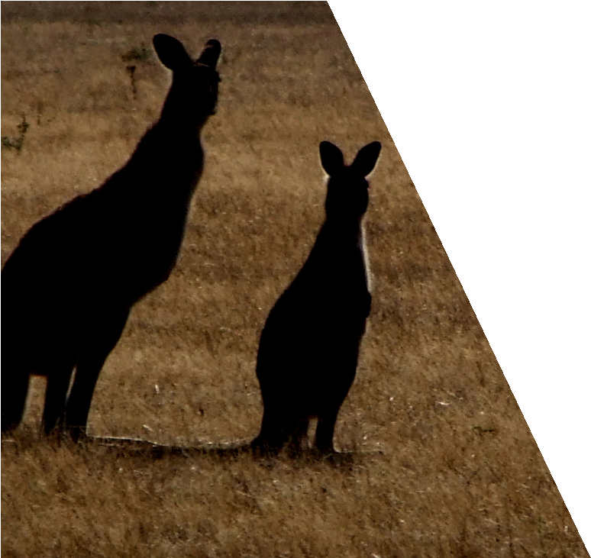
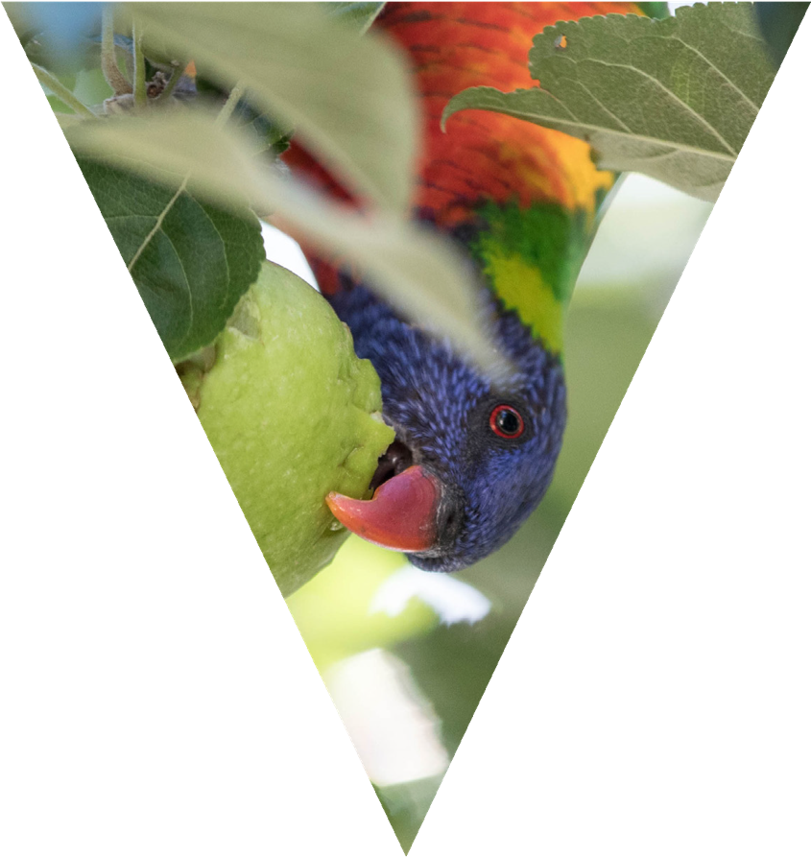

How to participate in the review

Your feedback is important to this review and will help shape the recommendations for improvements to the ATCW system. If you would like to provide a response to the questions raised in this discussion paper you can do so on the Engage Victoria website: engage.vic.gov.au/atcwreview
Alternatively, if you would like to request a hardcopy or email feedback form please contact the DELWP Customer Contact Centre on 136 186, or email: biodiversity.regulation@delwp.vic.gov.au
All submissions must be received by 5pm Friday 29 June 2018.
Once the consultation period closes, DELWP will review and consolidate the responses and publish a summary of the responses on the Engage Victoria website in August 2018.
The final recommendations on ways that the ATCW system could be improved will be provided to the Minister for Energy, Environment and Climate Change in September 2018.
If you require further information or assistance completing a response, please contact the DELWP Customer Contact Centre on 136 186 or email: biodiversity.regulation@delwp.vic.gov.au.

Department of Environment, Land, Water and Planning

33

delwp.vic.gov.au

